windows10 python3.7 OpenSSL 1.1.1a 20 Nov 2018

1,make sure that you prepared device certificates using scripts

<https://github.com/kmwebnet/ECC608-Provision/tree/master/scripts>

you can prepare device certs from manifest file in certs/ folder as follows:

0123XXXXXXXXXXXX01.pem

2,create Azure IoT Hub and Azure IoT DPS Service in your Azure account.

you can make sure them as follows if you pinned to your dashboard.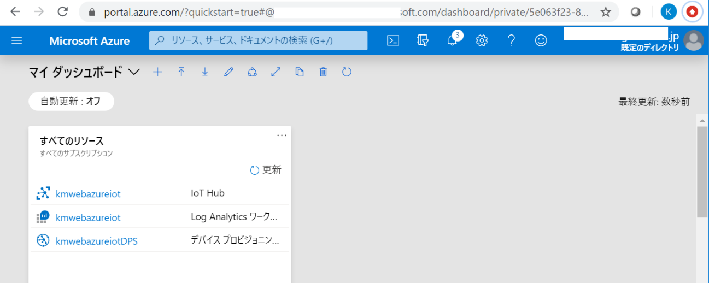

3,setup your Azure IoT DPS service

you need to record some items as highlighted below to execute latter steps.

a, global device endpoint URL(This seems to be common to all users)

b, ID Scope

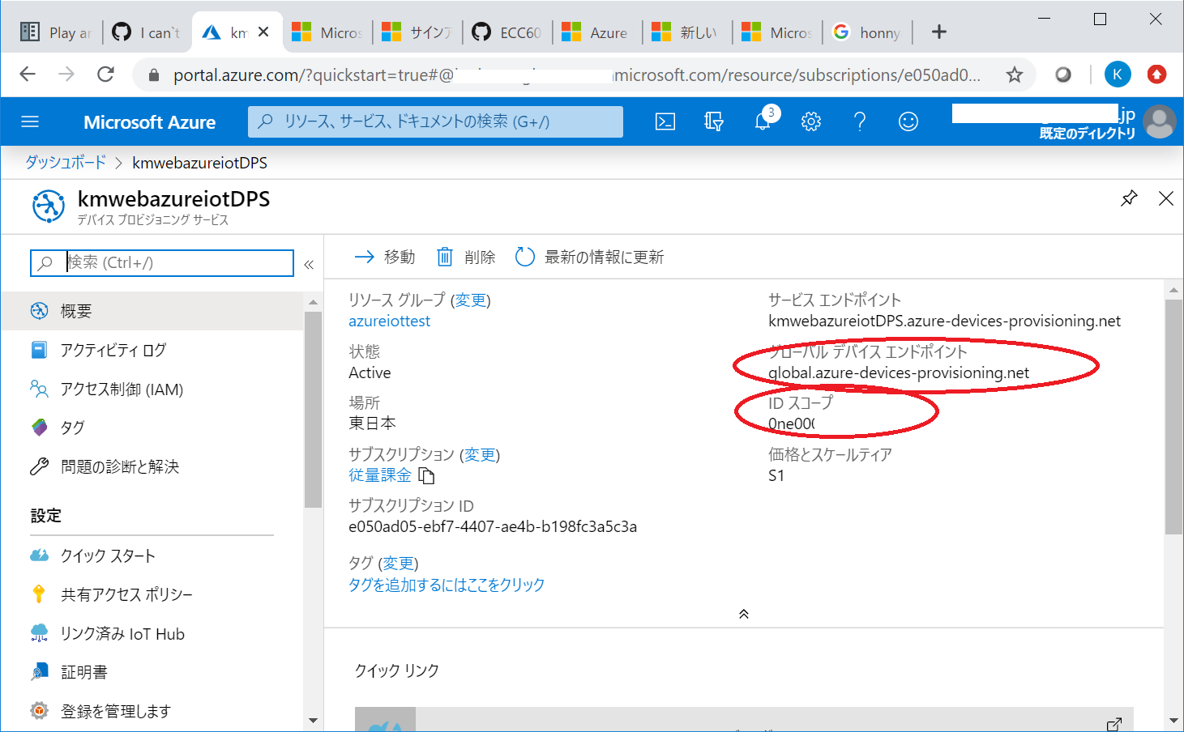

make sure your Azure DPS is linked to your Azure IoT by checking “Linked Hub” menu.

if it's not, you need to set as follows:

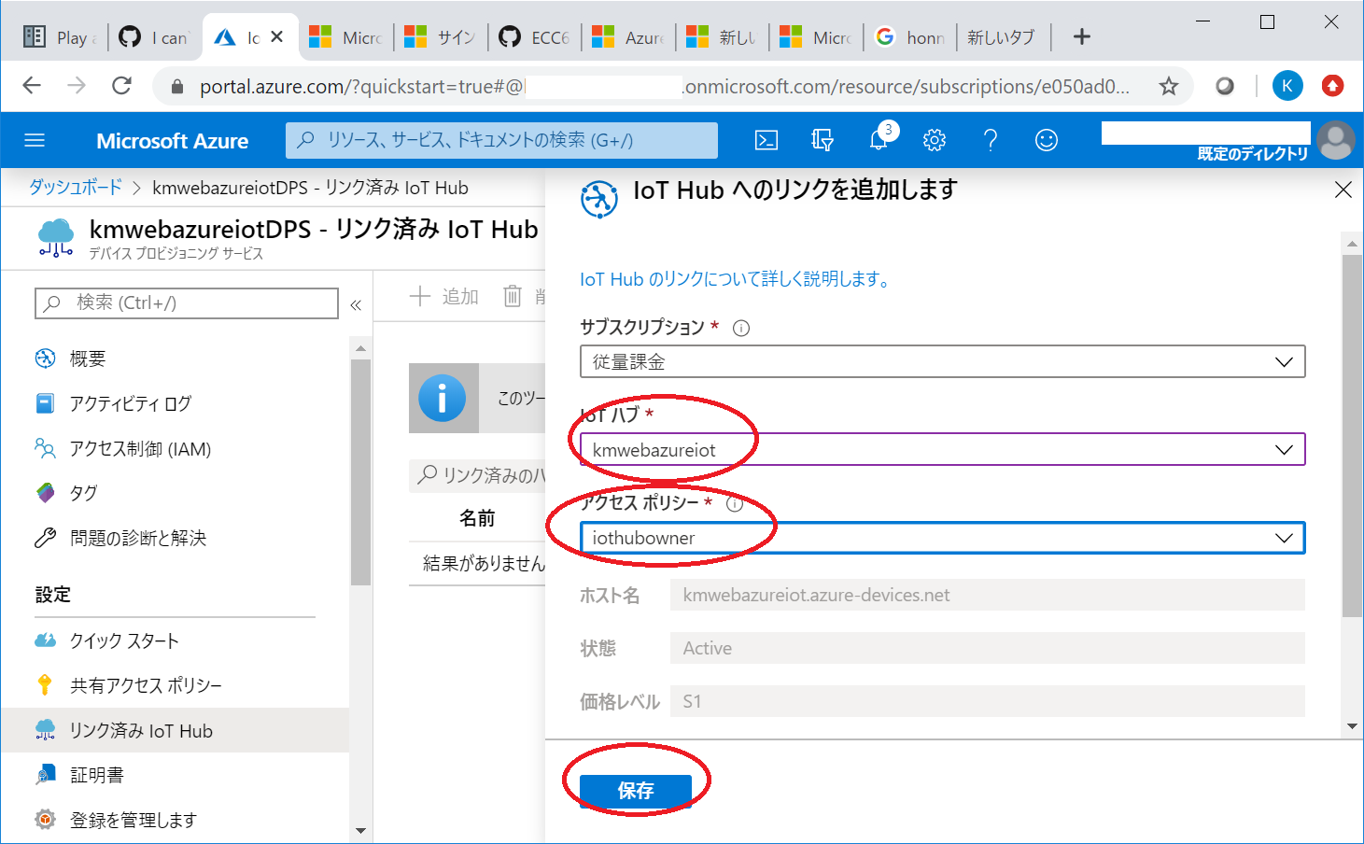

4,upload device certificate created above.

you use “individual enrollment” to upload.

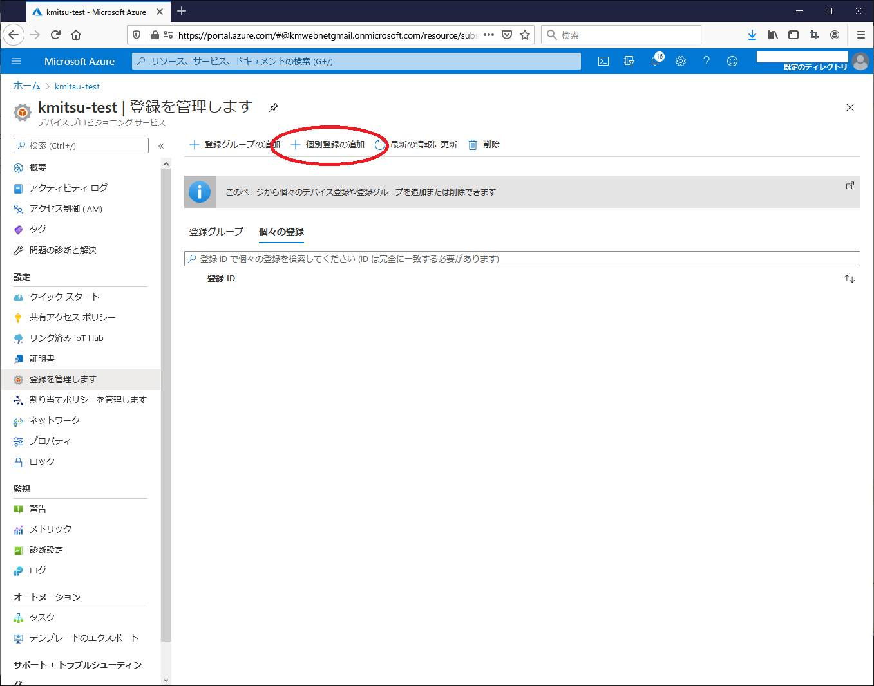

make sure primary certificate selection and “linked Hub” contents.

in this Example, I set a value exactly as same as device cert’s common name in ”Device ID” field.

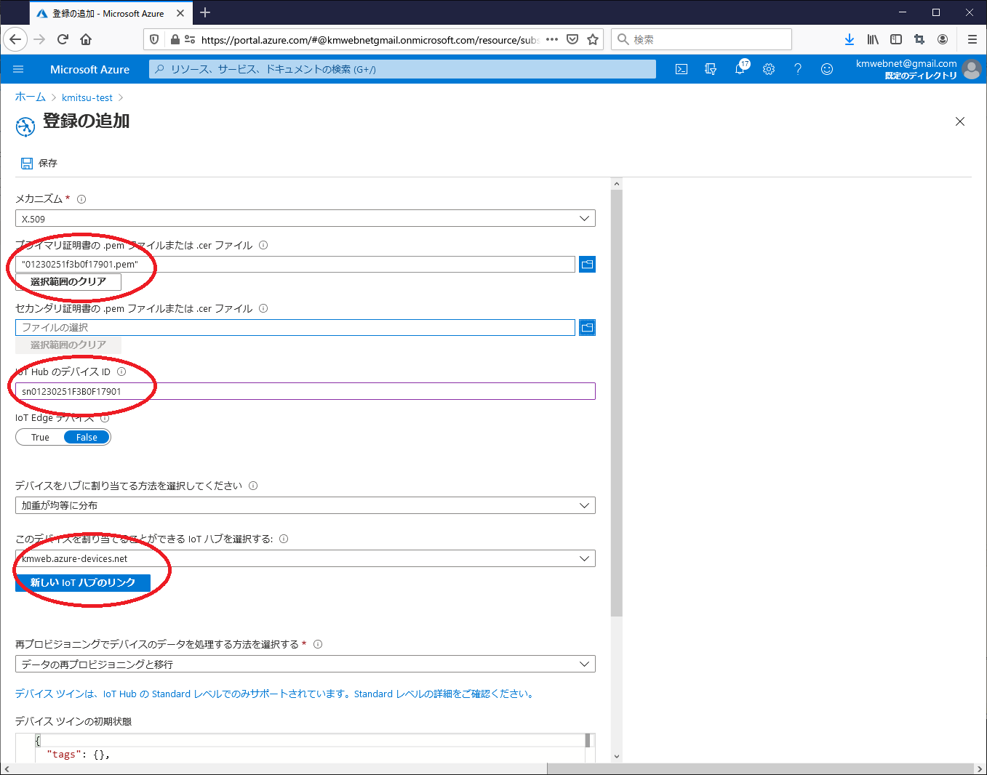

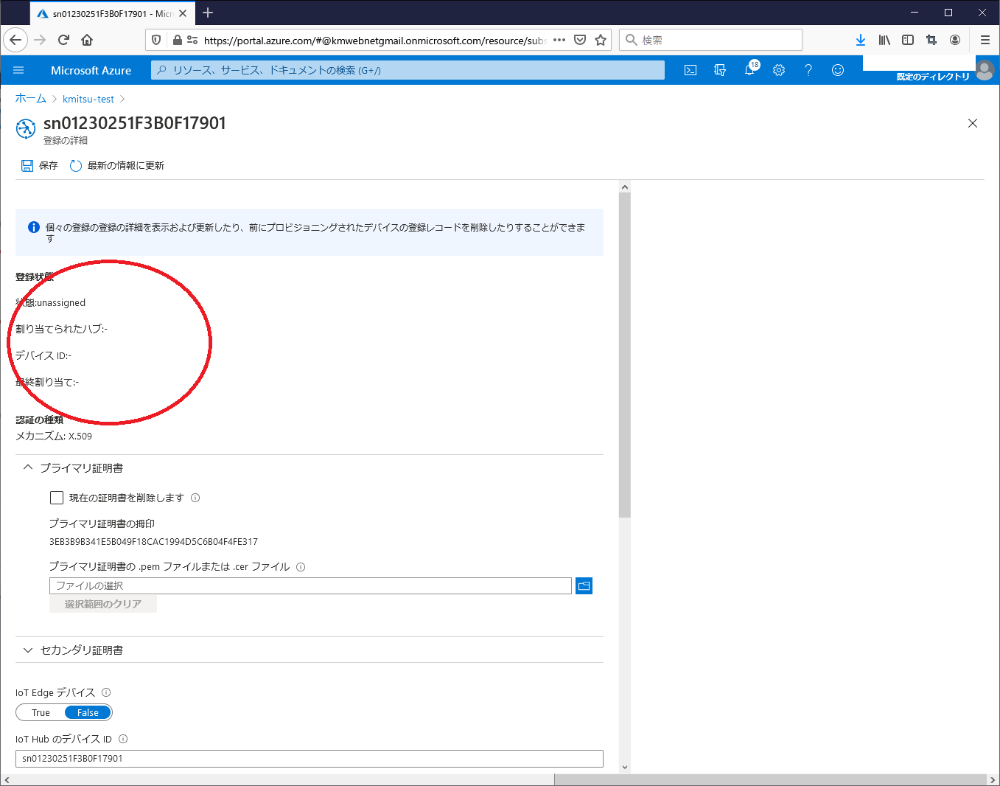

at this point, you can see their status are “Unassigned”.

5, Compile and Run

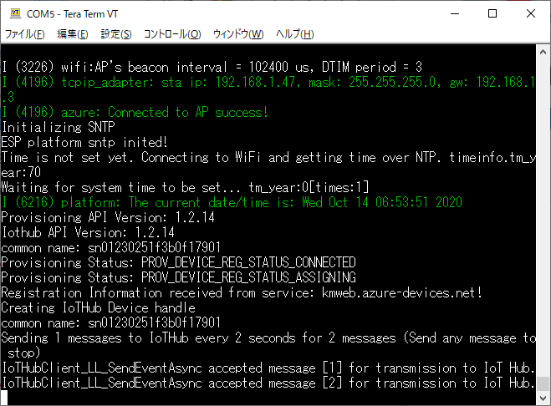

you can check updated provisioning status on device’s serial console.

And connections hand over on Azure IoT hub from DPS.

6, make sure Azure IoT connection

On your DPS, you can check as follows:

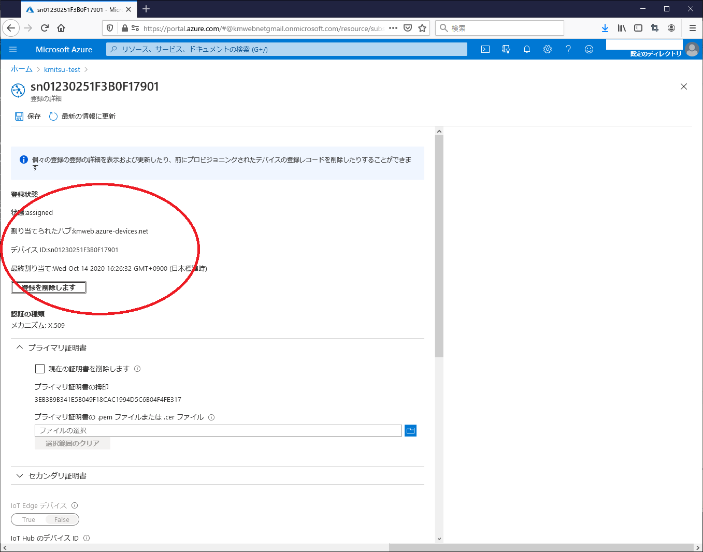

on your Azure IoT Hub, you can check as follows:

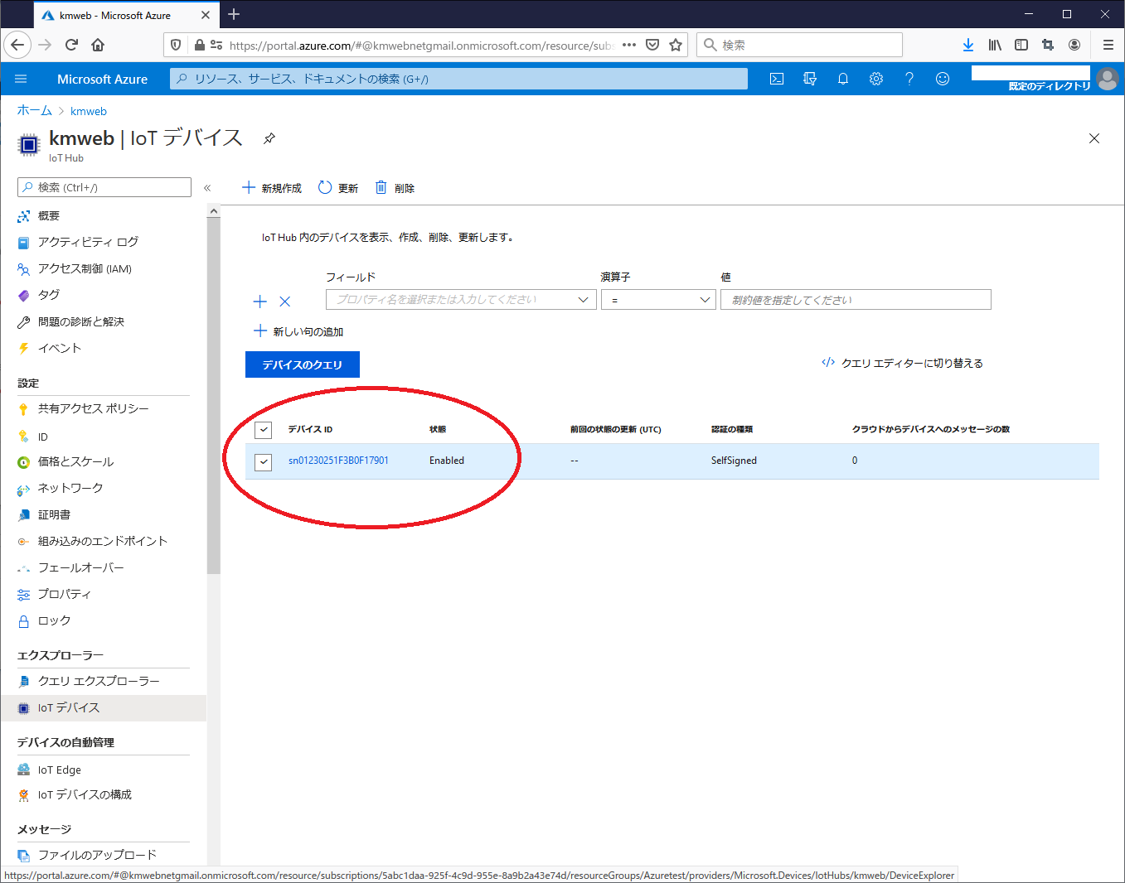

finished preparation for certificates on Azure IoT.